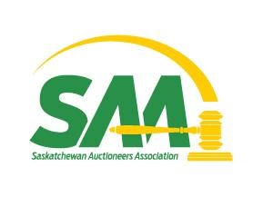
Post Convention News 2026

CONVENTION AND AUCTION ERA INDUCTION HELD
A very successful convention and Auction Era Induction ceremony was held on Saturday, August 15, 2026, at the Western Development Museum in North Battleford, SK. The Boards of Directors and Trustees held their annual combined meeting prior to the AGM, with 8 members attending. Meeting reports will be published elsewhere in this newsletter.
New to the convention for 2026, the first “Legacy Award” recipient was honored. Three deserving former auctioneers were honored with induction into the Auction Era Hall of Honor, and a successful fundraising auction followed. Reports on honorees follow in this newsletter.

Boards of Directors/Trustees meeting:
August 15, 2026: A pre-AGM meeting of the Boards of Directors and Trustees was held at 10:30 am on Saturday, August 15, 2026 at the Western Development Museum in North Battleford. Eight members were present, with three regrets. Minutes of the previous meetings were adopted, convention and induction details were finalized, and reports to convention were confirmed.
Resolutions to convention were approved for submission, and Board of Trustee appointments were made. The Secretary, Jo-Ann Ganzert, was appointed for a further term, with salary and rent remaining at 2024 levels. Discussion occurred on charging PST on online sales, and the occurrences of credit card fraud throughout the province. Discussion also occurred on communication between auction companies when fraudulent transactions are noticed.
The next meeting will be held immediately following the AGM, to organize for the coming year.

Annual General Meeting:
. The Annual General Meeting convened at 2:00 pm on Saturday, August 15, 2026 at the Western Development Museum in North Battleford. Ten delegates were present. Thanks were extended to the sponsors of convention: CJWW Radio, CKRM Radio, GX94 Radio, CJNB Radio, and Pattison Media. A moment of silence was observed for two past members who passed in the year: Richard Barnsley, and Geroge Leichert. Reports were received to file.
Resolutions were passed as follows: That Ryan Moore be appointed to assist with accounting procedures for the year 2026. That the 2027 convention be held on January 27, 2027, via TEAMS meeting. That the board remuneration for 2026 be held at 0.00 per meeting, and 0.00 per km travel. In lieu of payment, the board will make a $500 payment to a charity of choice, determined at the 2027 AGM.
There were two Board of Director vacancies, and Scott Johnstone and Norman Mack were declared by acclamation. The Board of Directors appointed Loren McDougall and Scott Johnstone to three year terms.

First Annual Legacy Award:
The SAA is proud to have presented the First Annual Legacy Award at the recent AGM and Convention. Criteria for the award includes: Must have been a board member of the SAA, and must have contributed significantly to the operation, growth of the SAA, and must have shown leadership. The honoree must also have shown a pride, passion and loyalty to the SAA, and it could be awarded posthumously. We were extremely proud to present the first award to Barrie Jung, and were pleased that Barrie’s widow, Tanis and their two children, Devin and Kendra were present to receive the award. Barrie passed away in April of 2024, and is missed greatly by the SAA.
Also announced at the presentation, the award will be named “THE BARRIE JUNG MEMORIAL LEGACY AWARD’ in the future.
In addition to the acceptance speech that Tanis gave, Barrie’s daughter Kendra wishes to add the following:
“Good evening, everyone. On behalf of my Mom and brother, thank you so much for honoring Barrie with this award. I have always known my Dad to be a very hard-working man. When I was growing up, unfortunately, he had to be away a lot. As a kid, I didn’t always love that part of his job, but as I got older, I realized that it also gave us some pretty amazing opportunities and experiences.
I got to travel with him to the Calgary Stampede year after year when he was tractor pulling, and he would even let me bring a friend along. Those are memories I will carry with me forever, and I am incredibly grateful for the life and opportunities his career gave our family.
My dad was such a kind and loving man. Now, I am sure there are a few people who worked for him who may have a slightly different story about just how kind he could be when things got stressful! But he truly loved what he did. I was always fascinated by his people skills and his ability to stand in front of a crowd and confidently do what I find terrifying. I absolutely hate public speaking .. don’t get me wrong, I love to talk, and I’m pretty loud about it, just not in front of a crowd with a microphone. So, watching my dad get up in front of so many people and effortlessly use his auctioning skills was something I thought was so incredibly cool. Of course, I would make him do it for all my friends whenever I could!
He was a loving father, husband, a brother, a son, a friend, a sponsor and a great auctioneer. Most importantly, he was someone who made an impact on the people around him. We miss him every day, and it means so much to us to know that the work he loved and the person he was are still being remembered. Thank you for honoring my Dad tonight. We are incredibly proud to accept this award!”

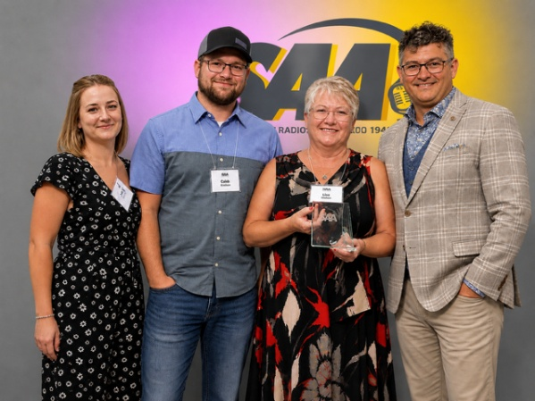

Kendra, Devin and Tanis Jung, Kelly Clarke

AUCTION ERA 2026: Three worthy retired auctioneers were inducted into the Auction Era Hall of Honor at convention: Rick Elias of Melville, Paul Moore of Yorkton, and Ross Taylor of Reston, MB. They celebrated with family and friends who attended to witness the induction.

Rick Elias was active from March 1988 until March 2021. His auction history included working with Glenn Striker, Keith Talbot Auctions, Brad Stenberg, Blair Stenberg, Dale Breiman, Richard Mierau, Mike Fleury, Tim Manz, the Haggart clan of Abbey, SK, John Wiebe, Wayne Cory, Doug Gillespie, Kevin Hooper, and Gerald Berg. He worked with Jason LeBlanc of Estevan, and when Jason sold to Ritchie Bros in 2004, Rick worked for them until 2021. There, he worked with many great auctioneers: Lorne Campbell, Des Plewman, Blair Stenberg, Mason Richard, Kevin Hooper, Scott Johnstone, Robert Ross, Paul Moore, Grant, Jordan and Dareen Clarke, Kelly Clarke, Neil, Kim and Brendan Kramer, Scott Meiklejohn, and many auctioneers from Ritchie Bros. His charity auction history is lengthy including many in the Hodgeville and Melville areas. Married to Colleen for 34 years, Rick thanked her and their daughter Melanie, along with the rest of his family for their support over the many years.
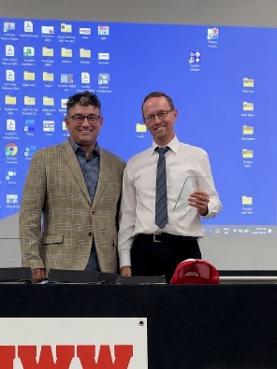
Kelly Clarke and Rick Elias

Paul Moore went to auction school in 1979, where he finished in the top 15 of 125 students. He worked various jobs until late 1996, when he was hired to sell 3 livestock markets per week in Norquay, Roblin and Sturgis. The 2003 BSE outbreak saw a change in venues, and Paul began selling with Stampede Auction in Yorkton. In 2008 Paul purchased the auction business, and Yorkton Auction Centre was born. Building the auction centre into a very successful business, Paul saw the business grow at a rate of 20% each year. The business grew to include a yard site of 30 acres, filled to the brim for most sales. In 2024, Paul retired, and sold the business to his son Jamie. Paul served on the board of Directors of the SAA from 2015-2019, was Vice-President in 2018 and 2019. He attended many conventions, and his thoughtful input was always gratefully received. Married to Shannon, they are the proud parents of four sons, and 13 grandchildren.
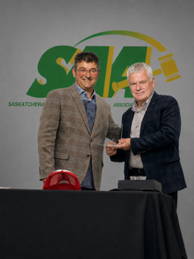
_____________________________________________________________________________

Ross Taylor began his auction career in 1971 at Melita Auction Mart, gaining valuable experience and built a strong foundation in the cattle and auctioneering business. After attending auction school in 1982, he began working with Ron Wilkinson Auction Services in 1985, purchasing the business in 1996, establishing Ross Taylor Auction Services. That same year, he won the MAA Auctioneers Competition in Winnipeg, and went on to compete at the Canadian Championships. A versatile auctioneer, Ross sold farm, livestock, antiques, estate sales, and household contents. He became a trusted and respected name across the auctioneering community and through out the prairie provinces. During this time, he generously donated his auctioneering skills to many fundraising charities throughout the area. Purchasing the Melita Auction Mart in 2004, they diversified their business: handling thousand of livestock sales, as well as farm real estate and consignment auctions. As an active SAA member, Ross and his wife Pat attended many conventions, and Ross served on the Board of Directors from 2011-2013, and was a Board of Trustee member in 2017 and 2018. He retired in 2018.
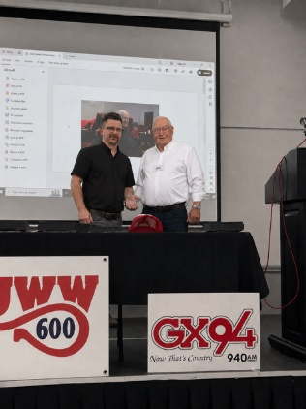

Board Elections and Appointments:
The three year terms of Scott Johnstone and Frederick Bodnarus expired this year. Frederick was not eligible for re-election, as he was completing his 2nd term. Scott, completing his first term, was eligible for re-election. Loren McDougall’s first three year term on the Board of Trustees expired, and he was eligible for re-appointment by the Board of Directors to a second term. At the recent AGM, Scott Johnstone and Norman Mack were elected to three year terms on the Board of Directors, and Loren McDougall and Scott Johnstone were appointed to three year terms on the Board of Trustees.
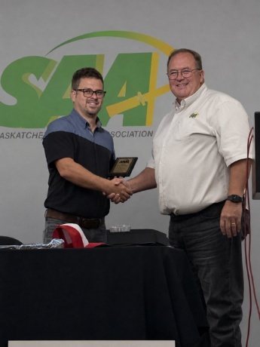
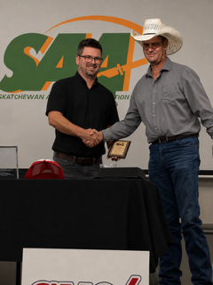
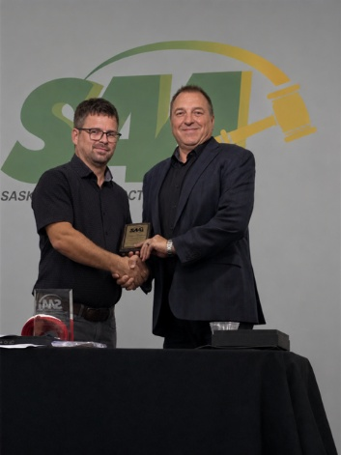
Jamie Moore, outgoing President presenting to
Scott Johnstone,
Frederick Bodnarus and
Loren McDougall

Agribition 2026: Canadian Western Agribition will be held November 23 – 28, 2026, in Regina. We expect there again will be Agri-Ed Auctions, where school students attend a mock auction, presented by volunteer auctioneers. Included at the events are the sale of “Grand Champion Bidder” caps, for real money, which is donated to the CWA Scholarship fund. A long-time tradition, we are proud to have raised over $25,000 for this fund over the years. Further details of the sales will be emailed to members once schedules and venues are finalized. We urge any auctioneers attending Agribition to attend the sales
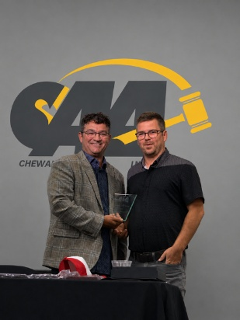
Incoming President Kelly Clarke,
with Past-President Jamie Moore

Directors for 2026
Dan Heslip Regina 2nd Term expires 2026
Tracey Vereshine Saskatoon 1st Term expires 2026
Kelly Clarke Lumsden 2nd Term expires 2026
Scott Johnstone Moose Jaw 2nd Term expires 2028
Norman Mack Estevan 1st Term expires 2028
Jamie Moore Yorkton 2nd Term expires 2027
Kelly Schneider Medstead 1st Term expires 2027

President Kelly Clarke
Vice-President Dan Heslip
Treasurer Kelly Schneider
Past President Jamie Moore

Board of Trustees 2026

Neil Kramer Battleford 1st Term expires 2026
Loren McDougall Regina 2nd Term expires 2028
Norman Mack Estevan 1st Term expires 2027
Scott Johnstone Moose Jaw 1st Term expires 2028
Kelly Clarke Lumsden (as President)
Jo-Ann Ganzert North Battleford ex-officio

Committees 2026
A unanimous decision by the Board of Directors was to have the entire board as members on every committee: Legislation, Agribition, Convention, Resolutions, Nominations, Grievance/Liaison, Auction Era and Membership

Box 773 North Battleford, SK S9A 2Y9 phone 306-441-2265 email: saskauctioneers@gmail.com www.saskauctioneers.com

